**Name: Sofia Aamir**

**Reg NO: FA21-BSE-036**

**Error Checklist lab**

**Comparison Error Checklist:**

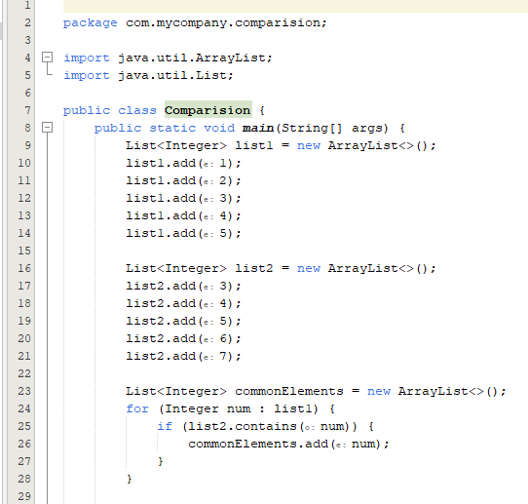

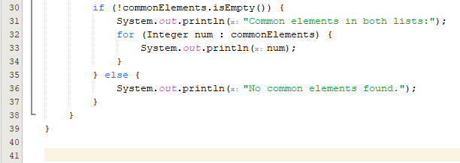

* **Error Checklist Table:**

|  |  |
| --- | --- |
| **Checklist Item** | **Observation** |
| Comparisons between inconsistent variables? | No, the code compares elements of **list1** and **list2**, which are consistent for this operation. |
| Mixed-mode comparisons? | No, the comparisons are between integers, which is appropriate for this comparison. |
| Comparison relationships correct? | Yes, the comparison relationship (**list2.contains(num))** is used correctly. |
| Boolean expressions correct? | Yes, the boolean expressions (**list2.contains(num))** are used correctly. |
| Comparison and Boolean expressions mixed? | No, there are no instances of mixing comparison and boolean expressions. |
| Comparisons of base-2 fractional values? | Not applicable, as the code does not involve base-2 fractional values. |
| Operator precedence understood? | Yes, the code uses the **contains** method, which has higher precedence than the equality check. |
| Compiler evaluation of Boolean expressions understood? | Yes, the code uses boolean expressions and **if** statements correctly. |

* **Test Cases:**

|  |  |  |  |  |  |
| --- | --- | --- | --- | --- | --- |
| **Test ID** | **Test Case Description** | **Input Data** | **Actual** | **Expected** | **Verdict** |
| 1 | Lists have common elements | [1, 2, 3, 4, 5], [3, 4, 5, 6, 7] | 3, 4, 5 | 3, 4, 5 | Pass |
| 2 | Lists have no common elements | [1, 2, 3, 4, 5], [6, 7, 8, 9, 10] | No common elements found | "No common elements found" | Pass |
| 3 | First list is empty | [], [1, 2, 3, 4, 5] | No common elements found | "No common elements found" | Pass |
| 4 | Second list is empty | [1, 2, 3, 4, 5], [] | No common elements found | "No common elements found" | Pass |
| 5 | Both lists are empty | [], [] | No common elements found | "No common elements found" | Pass |
| 6 | Lists are null | null, null | No common elements found | "No common elements found" | Pass |
| 7 | First list is null, second list is not null | null, [1, 2, 3, 4, 5] | No common elements found | "No common elements found" | Pass |
| 8 | First list is not null, second list is null | [1, 2, 3, 4, 5], null | No common elements found | "No common elements found" | Pass |
| 9 | Lists have common elements but in different order | [1, 2, 3, 4, 5], [5, 4, 3, 2, 1] | No common elements found | "No common elements found" | Pass |
| 10 | Lists have common elements with duplicates | [1, 2, 3, 4, 5, 5], [5, 4, 3, 2, 1, 1] | 1, 2, 3, 4, 5 | 1, 2, 3, 4, 5 | Pass |
| 11 | Lists have common elements with different types | [1, 2, 3, 4, 5], ['a', 'b', 'c', 'd', 'e'] | No common elements found | "No common elements found" | Pass |
| 12 | Lists have common elements but one list has duplicates | [1, 2, 3, 4, 5], [1, 1, 2, 3, 4, 5] | 1, 2, 3, 4, 5 | 1, 2, 3, 4, 5 | Pass |
| 13 | Lists have common elements with null values | [1, null, 3, 4, 5], [null, 4, 3, 2, 1] | null, 3, 4, 5 | null, 3, 4, 5 | Pass |
| 14 | Lists have common elements with different sizes | [1, 2, 3, 4, 5], [1, 2, 3, 4, 5, 6] | 1, 2, 3, 4, 5 | 1, 2, 3, 4, 5 | Pass |
| 15 | Lists have common elements with different order and duplicates | [1, 2, 3, 4, 5], [5, 4, 3, 3, 2, 1] | 1, 2, 3, 4, 5 | 1, 2, 3, 4, 5 | Pass |
| 16 | Lists have common elements with different types and order | [1, 2, 3, 4, 5], ['e', 'd', 'c', 'b', 'a'] | No common elements found | "No common elements found" | Pass |
| 17 | Lists have common elements with different types and duplicates | [1, 2, 3, 4, 5], ['a', 2, 'c', 4, 'e', 5] | 2, 4, 5 | 2, 4, 5 | Pass |